HILLY FIELDS FOOTBALL CLUB
SEASON 1: 1967-68
FIRST TEAM:
IMPERIAL LEAGUE:
P W D L F A pts Pos
Division 2 18 10 2 6 84 52 22 3rd Challenge Cup 3 2 0 1 8 11
TOTAL 21 12 2 7 92 63

Apps Gls Apps Gls
Billy Attwater 12 3 Chris Green 18 26
Brian Barber 8 2 Ray Griffin 18 0
Pete Barber 5 1 John Harding 11 0
Fred Beal 1 0 Bobby Head 19 18
Phil Clover 14 11 Bill Irwin 2 0
Ron Davis 13 6 John MacRea 9 0
Keith Dumbleton 2 0 Ian Parsons 8 0
Martin Formosa 20 1 Tom Pollard 18 5
Len Franklin 18 10 Frank Ryan 20 2
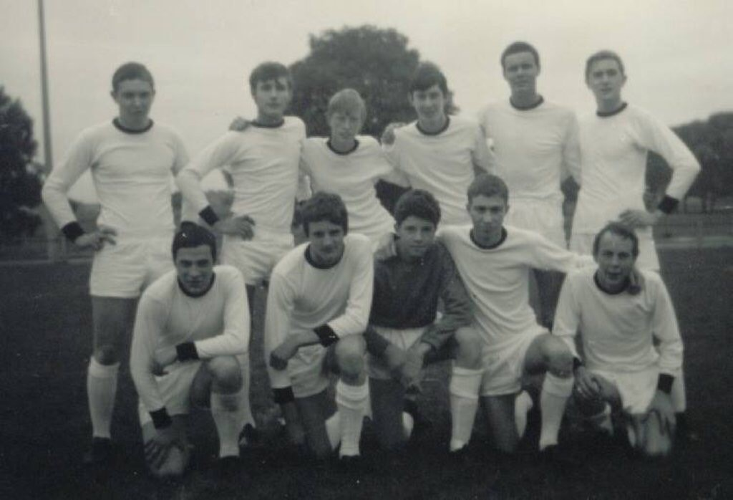
Larry Garnham 15 2 OG 5
L-R Back: Phil Clover, Tom Pollard, Larry Garnham, Frank Ryan, Billy Attwater, Len Franklin.
L-R Front: Martin Formosa, Bobby Head, John Harding, Chris Green, Ray Griffin.

